

**EQUALITY DIVERSITY AND INCLUSION ANNUAL REPORT**

**2023/24**



**1.** **Introduction** 3

**2.** **Highlights 2023** 3

**3.** **Accountability and Governance** 3

**4.** **EDI Priorities** 4

**5.** **EDI Relevant Working Groups** 9

**6.** **Race Equality Work** 9

**7.** **EDI initiatives from the University research community** 11

**8.** **Staff Engagement through Staff Networks** 12

**9.** **Campus, Place and Communities** 14

**10.** **Benchmarking- Staff Diversity Data** 15

**11.** **Going Forward in 2024/25** 17

**FOREWORD**

The past year has been a pivotal period in our ongoing journey toward fostering Equality, Diversity, and Inclusion (EDI) within our UON community. As we present this annual report, we reflect on the strides made, the lessons learned, and the challenges that remain. Our commitment to EDI is not just a strategic priority but a core value that underpins everything we do. It is a continuous effort to create a campus and workplace where everyone feels valued, respected, and empowered to reach their full potential.

This report outlines the initiatives, achievements, and areas for growth in our EDI efforts. It highlights the voices of those who have contributed to our collective progress and those whose experiences underscore the importance of this work. From policy changes and development programmes, to community engagement and giving voice and offering safe spaces to colleagues and students, we are proud of the steps we have taken. However, we recognise that there is always more to be done. True inclusion is an ongoing journey, not a destination.

Our approach to EDI is holistic and intersectional, recognising that diversity extends beyond visible characteristics and includes diverse perspectives, experiences, and identities. We strive to dismantle systemic barriers and build an environment where everyone, regardless of their background, can thrive. This commitment is reflected in our actions and the metrics we use to measure our progress.

As you read through this report, we hope you find not only an account of our activities and achievements but also inspiration and encouragement to join us in this vital work. EDI is a shared responsibility, and we invite you to engage with us in creating a more inclusive future. We are grateful to all those across UON who have contributed to these efforts, and we look forward to continuing this essential journey together.

**Professor Anne-Marie Kilday**

**Vice Chancellor**

# **Introduction**

This report provides an overview of the work undertaken during the academic year 2023/24 to promote equity, diversity and inclusion (EDI) across our staff community at the University of Northampton. It also sets out our new way of reporting which will follow the academic year.

The report meets our legal obligation to comply with the Equality Act 2010 and the Public Sector Equality Duty it creates. It can also be argued that the University also has a moral obligation to perform this duty.

The Public Sector Equality Duty states that the University must have due regard to the need to:

* eliminate discrimination, harassment, victimisation and any other conduct that is prohibited by the Equality Act
* advance equality of opportunity between persons who share a relevant protected characteristic and persons who do not share it
* foster good relations between persons who share a relevant protected characteristic and persons who do not share it

1. **Highlights 2023**

Our highlights and main achievements for 2023 include.

* Introduced a new EDI governance structure
* Reviewed our EDI Rolling Action Plan 2020-25 to ensure it remained focused
* Launched a Race Equality Project to progress our anti-racism work
* Increase in staff engagement through increased number of staff networks and targeted initiatives

1. **Accountability and Governance**

2023 saw the consolidation of our EDI work with the establishment and expansion of the EDI team and merging with the Access and Participation Team to form the Equality and Access Team, within the Vice Chancellor’s Office.

We reviewed actions from the EDI Rolling Action Plan to ensure that we maintain momentum and can invest our resources in the targeted areas. We established a new governance structure for EDI across the organisation headed by the EDI Forum and aimed at increasing the student voice in our decision making across the University.

Chaired by the Vice-Chancellor the EDI Forum is responsible for assessing progress against all EDI Initiatives and ensuring that there is accountability of EDI Initiatives across the University.

Our 5-year strategy ends next year and as we move towards the final year of the current strategy and action plan, we want to ensure that we have achieved our KPIs and that there is a drive towards a positive cultural change across the University.

1. **EDI Priorities**

Our EDI work covers 3 themes, recruitment which is our drive to recruit, retain and develop a diverse workforce across the organisation, workforce development and training which focuses on creating inclusive behaviours across the organisation through provision of awareness raising and training initiatives across EDI and increasing a sense of staff and student belongingwhich involves increased staff and student engagement and creating ‘safe spaces’ for all in the University. Delivery against the themes is achieved within our revised EDI Action Plan, Race Equality Project Workstreams and the Empowering the Black Professional project.

* 1. **Recruiting a diverse workforce and Inclusion**

Our aim is to:

• *Increase proportion of those with protected characteristics, in particular Women, GEM members of staff and people with disabilities, in senior positions (grade 9 and above), ensuring diversity reflects the workforce population  
• Continual reduction of the ethnicity and gender pay gaps  
• Improve inclusion and progressions for those with protected characteristics across the workforce demonstrated through equality of opportunity and outcomes  
• Improve inclusion for staff with disabilities ensuring efficient and supportive reasonable adjustments are provided  
• Build awareness and education around ethnicity, LGBT+ and disability in the workplace  
• Increase confidence in those with protected characteristics that they can trust us*

Over the past year we have seen an increase in the proportion of female employees in senior grades across the organisation standing at 50% in 2023 compared to 39% in 2022.

Our ethnicity data shows that about 27% of our Global Ethnic Majority (GEM members of staff are within the grades of nine and above. Our data informs our other projects where we have targeted interventions to support diverse groups within the GEM group.

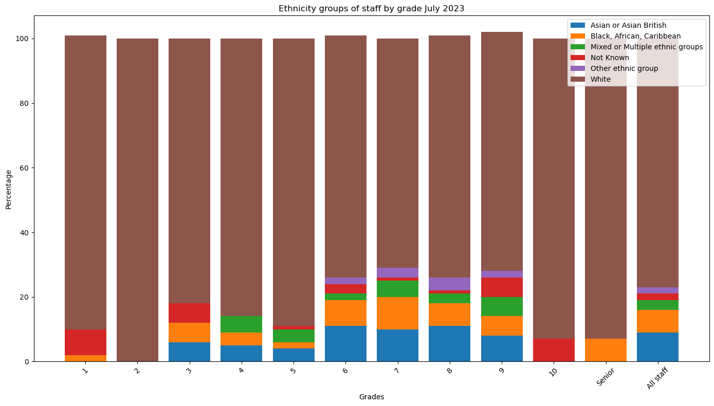

We continue to provide disability pay gap data to ensure that we can direct our work in a more focused way. Several actions have been agreed within the disability pay gap analysis reporting and this will be taken forward in the coming months.

About 20% of colleagues with disabilities are represented in Grades 9 and above as of July 2023.

* 1. **Workforce development**

*Ensure inclusive behaviour and awareness of EDI through training, communication, management and leadership practices with particular regard to BAME, disability and LGBT+  
 Create a culture where staff feel able to talk about and be themselves.  
The potential of all members of the University community is recognised and actively encouraged*

Several EDI relevant courses are on offer through the Staff Development Team, as well as through LinkedIn offered through the team for academic and professional services staff.

* Equality and Diversity Essentials: 483 completions
* Challenging Unconscious Bias E-Learning: ninety completions
* Cultural Inclusion Workshops (staff) four teams – 63 people
* Cultural Inclusion Workshops train the trainer (to deliver the student version) – 7 people
* LGBT+ Awareness – 31
* How to be a Good Ally – 27
* Confronting Gender Bias – 16
* Race Equality - 12
* Union Black – 26 Completed last year – 248 registered and at various stages of completion.

In addition, we had 453 viewers of LinkedIn Learning courses or learning paths identified as EDI related.

Our Academic Practice staff offer the following courses to enhance our academic staff’s understanding of EDI so they can offer appropriate support to diverse students.

* [*Enhancing the engagement of your international students*](https://mypad.northampton.ac.uk/lte/2022/01/18/enhancing-the-engagement-of-your-chinese-students/)
* [*Supporting neurodivergent students in higher education*](https://mypad.northampton.ac.uk/lte/2022/01/18/working-with-students-on-the-autism-spectrum/)
* [*Learning and teaching for LGBTQ+ inclusivity*](https://mypad.northampton.ac.uk/lte/2022/05/12/learning-and-teaching-for-lgbtq-inclusivity/)
* [*Decolonising yourself and your learning and teaching*](https://mypad.northampton.ac.uk/lte/decolonising-yourself-and-your-lt/)

Awareness raising of EDI has also been driven through several initiatives such as through the Library, Learning and Student Services, (LLS) initiative of *So Here’s the thing* exploring various topics including EDI topics. This has included Neuro-diversity awareness as part of Disability History month, Religion, and an understanding of Belief and Culture in HE to explore gaps within the organisation.

We are working to increase the uptake of EDI relevant courses across the organisation to help build inclusive behaviours, while also reflecting on gaps through initiating race training/ awareness as part of our race equality work.

* 1. **Staff engagement**

Over the year we have taken on board targeted projects to explore how we create a sense of belonging and increase staff engagement across the University.

*Building Belonging* was a short term (six month) Advance-HE facilitated project that offered a network of other universities working in the area alongside four facilitated events from Advance-HE and a survey on Belonging that allowed benchmarking of UON against other participants.

The aims of the project, chaired by our Estates, Library, Learning and Student Services and Learning and Teaching Engagement teams and supported by a cross organisational group, were to define belonging for the University of Northampton and embed the discourse of belonging throughout the University to appropriately influence strategy, operational planning and project development.

*At the University of Northampton, we believe belonging is multi-dimensional, and involves feeling valued, accepted, and connecting with the institution’s values. This sense of belonging is co-created and nurtured through inclusive practices, collaborative learning, supportive networks, opportunities and intuitive systems. Belonging is ongoing and dynamic, it goes beyond physical presence, encompassing emotional and intellectual engagement, fostering an environment where all members are empowered to thrive academically and personally.* **Belonging working group UON** **23/24**

Going forward there are several plans and initiatives to include Belonging in Access and Participation (APP), EDI, Drug and Alcohol Impact and the University Mental Health Charter projects.

Following a workshop with stakeholders across the University we want to disseminate and use the Theory of Change model to evaluate existing belonging projects so we start to understand the real changes that we are making.

We conducted a staff survey and focus groups among our staff regarding cultural, religious, and belief-related observances. The survey and focus groups aimed to assess the importance staff placed on celebrating various events, evaluate the level of support they wish to be provided by the University, and gather suggestions for enhancing inclusivity and support for diverse beliefs.

This data helps us tailor support and resources to better accommodate diverse celebrations.

To this end we have an emerging staff Faith and Belief Forum. This forum will address the gap identified by staff regarding cultural and religious diversity, providing a safe space for open dialogue and fostering understanding amongst our staff community.

We are increasing awareness of various inclusion events through better use of the University digital screens while making better use of our Inclusion Calendar.

Our Smarter Working Policy is currently under review and we want to use the revised policy to improve engagement and support managers to support staff who observe different holidays.

We produced guidance for our staff covering Ramadan, Passover and a Glossary of diversity terms which is on our intranet pages to engage our staff in their EDI work.

1. **EDI Relevant Working Groups**
   1. **Digital Accessibility Group**

We have re-established the Digital Accessibility Group to ensure that we remain on task around digital accessibility across the organisation.

Digital Services has introduced *ReciteMe*, the online accessibility and inclusion toolkit which now features on the UON external website as well as the Student Union (SU) web pages.

The Digital Accessibility Group is in the process of creating Digital Accessibility Champions across all departments to promote accountability across all teams. Our Digital Services team continue to ensure that all material for the website is accessible.

* 1. **Disability and Inclusion Coordinators Working Group**

The Disability and Inclusion Coordinators Working Group was re-established this academic year after a one year’s gap. The cross organisational group aims to identify and promote best practice across the University in disability, accessibility and inclusion ensuring that our policies, practices and estate are inclusive.

1. **Race Equality Work**

During 2023 we launched two new projects to support our drive to creating an anti-racist institution, the Race Equality Project and the Empowering the Black Professional Programme focusing on targeted initiatives to support our Black students and staff development.

The Race Equality project has 4 workstreams focusing on effective policy development through delivering against our Equality Impact Assessment (EIA) process and ensuring that EIAS are embedded in processes across the organisation, delivering an effective race training programme, developing our recruitment practices so we can develop a diverse talent pool and ensuring that we are communicating all our work effectively across the organisation.

* 1. **Develop a holistic approach to completion of Equality Impact Assessments across the organisation to develop an inclusive organisation**

We are currently reviewing our EIA process and working to embed the process within existing processes across the University and have established a working group to help with the review and accountability of EIAs. We still encounter challenges with the completion of EIAs for several policies, practices and procedures and we are continually reviewing this process to ensure our policies remain inclusive.

* 1. **Improve our learning and understanding of race and racism and its impact**

Our anti-racism training across the University is in initial stages and will be targeted at front-line services that work directly with our students. We are evaluating awareness raising and training that was offered through Santander Union Black so that we can understand where our staff are at in terms of race awareness.

* 1. **Increase diversity of our staff and support career progression for GEM Staff**

This area of work is on-going and embedded in our general recruitment drive across the organisation. We are working closely with the Talent Acquisition Manager to ensure we continually looking at strategies to support diverse recruitment.

Three GEM members participated in the Stellar HE Leadership programme with initial indications showing that participants have benefited immensely from taking part.

*I would 100% recommend this programme to other racially diverse staff at UON and hope UON continues to send more colleagues to complete this programme. It has provided me with so much more confidence to lead with impact and communicate to everyone around me of my values, authenticity and competencies.* **Participant Stellar HE 2023/24**

* 1. **Empowering the Black Professional (EBP)**

The EBP project focuses on several objectives which are;

Black student and staff voices and safe spaces, creating trust guidelines, mentorship of black staff and students, working to make the campus more aspirational and engaging for Black students (and commuter students) and use facilities to celebrate diversity and creating an inclusive curriculum.

We continue to seek ways to increase student voices in our strategic decisions and our current arrangements in the EDI Forum attempt to provide that space with representation from the staff and student voices.

To reduce the continued gap in advancement for GEM members of staff and reduce challenges for our Black students and staff we are developing a pilot mentoring programme. This pilot will form the basis of formal mentoring programmes to be replicated across the University to support other groups.

To further support colleagues’ sense of belonging, we are taking forward the ‘Say my name and use of pronouns’ initiative to support everyone across the University through standardising email signatures making it mandatory for all to provide correct pronunciation of names and optional use of pronouns.

Our campus space plays a vital role in supporting students and staff in building their sense of belonging and wellbeing. This year Catering Services has introduced student takeover days where students have made food from their country of origin to be sold in our main Café area and we want to build this into our calendar of events through the coming year.

We are taking forward the renaming of rooms across the University to ensure that the space resonates with our student community.

We are also working on a project to develop an inclusive learning toolkit for the organisation which will be embedded in the Learning and Teaching Strategy.

1. **EDI initiatives from the University research community**

The University research teams actively engaged in initiatives to promote Equality, Diversity, and Inclusion (EDI) within their work, demonstrating a commitment to fostering an inclusive and equitable research environment.

Some of the highlights include;

* Developed the UON Diamond Research Award 2023 for Justice, Equality, Diversity and Inclusion in Research
* Organisation of ‘Autism Study Day’ event
* Co-development of the ‘Inclusive learning in online education’ Module in joint collaboration with Trinity College Dublin.
* Hosting an Inclusive University international seminar series in collaboration.
* Research special interest group has focussed on the intersection of Diversity with Special Education and ‘increasing participation and co-production with minority groups.’ To this end, the SIG has conceptualised a research project focused on ‘Neurodiversity and people from ethnic and culturally diverse backgrounds.’
* Collaboration across Centres to provide the Building an Inclusive University 2022-2023 seminar series with themes on: ‘*Help or Hinderance - International agencies and post-colonial agenda*s.
* Centre for the Advancement of Racial Equality (CARE) held a summer conference in July 2023, and supported the development the film project ‘Breaking Barriers: Racism in HE’,
* CARE Research Seminars

‘Race and the Legal Profession: recovering lost lives from the archives’

CARE Research Seminar with external speakers from the magazine *The Other Side of Hope*

‘A Phenomenological Exploration of the Holistic Experiences of Students of African Descent as a Post-92 University in England’

* Black History, Country Houses and Anti-Slavery hosted as part of Black History Month celebrations
* Hosted the Holocaust Memorial Day event in February.

1. **Staff Engagement through Staff Networks**

We have seen an increased engagement with our staff through increased number of staff networks through the year with the establishment of the Parents and Carers Network to support parents and carers across the University, New Careers Network focusing on supporting and targeted development opportunities for those starting out in their career, and an emerging Faith and Belief Network.

This brings to eight the number of staff networks across the organisation with sponsorship available from senior members of the University Leadership Team (ULT) for all the established networks.

To support this continued engagement ULT agreed to a proposal to allocate facility time for network work, to the network leads and those that want to engage with the networks.

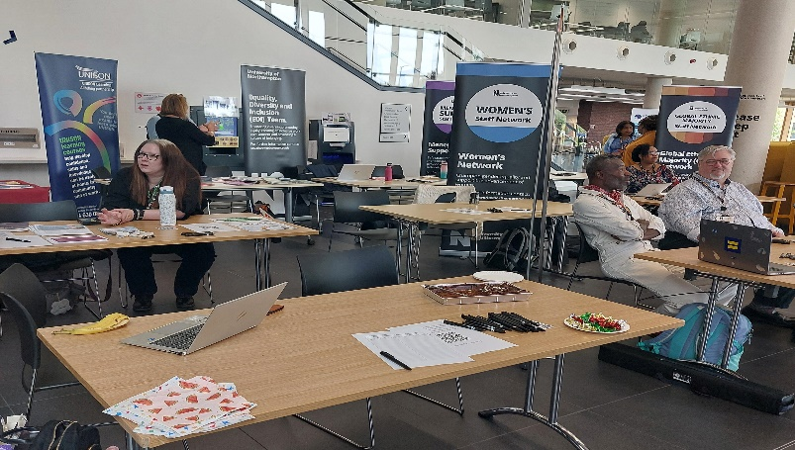**Staff Networks Awareness Day**

The EDI Team continues to chair monthly meetings for the Network Leaders which helps us explore and celebrate intersectional diversity and support our efforts to foster inclusion through celebration. We have produced guidance to build capacity for the staff networks and help strengthen their governance structures so they are better able to support members.

The LGBT+ network is currently leading on work to apply for the Stonewall Equality Workplace Index which will be the focus in the coming year.

* **Black History Month 2023:** We hosted a Black History Month celebration *GEM Connection* attended by staff, students and various members of the community which included African drums, dance and food and offered a curated reading list of books by Black authors which is now permanently available to our staff and students.

GEM network has continued to offer *GEM Talks* which offers a safe space for members to discuss any issues that they have. The Network is developing a strategy and action plan to support delivery of its work in the coming year

* **Disability History Month 2023:** Our Disability Network hosted several talks focusing on how to support neuro-diverse staff and students we work with both staff and students in putting together awareness raising events such as ‘Why disability history is important’, a roundtable to discuss lived experiences and a student enactment of the first ever case of dyslexia.

The Disability Network led on the planning for a staff sanctuary room, Eyrie which opened in June. The quiet space is for use by staff with ongoing conditions who may need a quiet space.

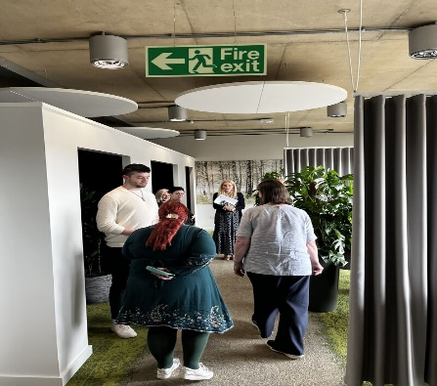

**Official opening of the Eyrie by the Vice Chancellor**

UON is a disability confident employer and to ensure that our disabled members of staff are valued and included, HR has developed a Workplace Adjustment Passport for use across the organisation.

**International Women's Week 2024:** UON and West Northants Women’s Networks collaborated in putting together an event that addressed imposter syndrome in Women of all ages and backgrounds. We hosted Ann Walsh, the chair of the Women’s Network at Google, who shared brilliant tips and affirmations to help overcome self-doubt and celebrate small wins.

The Parents and Carers Network hosted a Fertility Awareness and Support Training which was well received across the University.

We are committed to continuously improving our diversity and inclusion efforts. In the future, we plan to expand our celebration program to include additional cultural and heritage months. We will also explore additional ways to engage employees and further promote inclusive practices throughout the year.

# **Campus, Place and Communities**

During the past year, the University has also attended a series of community events which have celebrated members of our local community. Diwali, held on 4 November 2023, provided an opportunity for students and staff to participate in the annual Diwali procession. On 19 May 2024, an Eid celebration was held and in which the University took part as a stallholder raising awareness of the support offered through student and staff networks. Northampton Carnival, held on 8 June 2024 provided an opportunity to support one of Northampton’s largest cultural events.

For the second year in a row, the University hosted Northampton Pride on 13 July 2024, a celebration of the LGBTQ+ community and its allies in Northamptonshire. Over fifty stallholders representing a range of organisations came together to advertise their services to over 1,000 people who attended. A live music stage and a smaller spoken word stage provided entertainment for those attending. The event was organised by West Northamptonshire Council and sponsored by Barclays, Northampton Town Council, GXO Logistics and Northampton Business Improvement District. Barclays also sponsored a family zone which brought together entertainment for the youngest members of the community.

1. **Benchmarking- Staff Diversity Data**

Data is drawn from University records over the 22/23 year and represents an annual average figure. Sector benchmark data is taken from the Higher Education Staff Statistics: (HESA) UK, 2022/23, staff return.

**Age**

Twenty percent of academic staff in the sector were aged fifty-six and over.

|  |  |  |  |  |
| --- | --- | --- | --- | --- |
|  | % of staff 56 yrs. or over | Sector Benchmark | % of Academic staff 56yrs or over | Sector Benchmark |
| 2022/23 | 21% | 19.6 | 22% | 20% |

**Gender**

The University is above sector levels in terms of percentage of female staff overall and among academic staff. Female staff in HE accounted for 50% of full-time staff reported to HESA compared to the University’s 60% of our full-time permanent staff.

HESA Data shows there were more male academic staff than female. Forty-four percent of full-time academic staff were female. Numbers of females have increased on last year’s figures across the University.

|  |  |  |  |  |
| --- | --- | --- | --- | --- |
| Year | % of All staff Female | Sector Benchmark | % of Female Academic Staff | Sector Benchmark |
| 2022/23 | 61 | 50 | 55 | 44 |
| 2021/22 | 59.0 | 55.4 | 54.8 | 50.4 |
| 2020/21 | 58.7 | 54.9 | 54.2 | 49.6 |
| 2019/20 | 57.2 | 54.4 | 51 | 48.5 |
| 2018/19 | 57.9 | 55 | 52.2 | 48.2 |
| 2017/18 | 57.8 | 55.2 | 52.7 | 46 |

**Disability**

|  |  |  |  |  |  |
| --- | --- | --- | --- | --- | --- |
| Year | % of All Staff with a declared Disability | Sector Benchmark | % of Academic Staff with a declared Disability | Sector Benchmark | Not Known/ Refused |
| 2022/23 | 10 | 8.8 | 9 | 8.7 | 1 |
| 2021/22 | 9.1 | 7 | 8.5 | 6.2 | 1.2 |
| 2020/21 | 8.8 | 6.2 | 8.5 | 5.4 | 1.6 |
| 2019/20 | 8.4 | 5.5 | 8.1 | 5.5 | 1.8 |
| 2018/19 | 8.2 | 5.2 | 8.7 | 4.3 | 2.1 |
| 2017/18 | 8 | 5 | 8.5 | 4.4 | 2.2 |

The number of staff known to have a disability increased across the sector. The University has also seen an increase in numbers declaring a disability.

**Ethnicity**

|  |  |  |  |  |
| --- | --- | --- | --- | --- |
| Year | % of GEM Staff All Staff | Sector Benchmark | % of GEM Academic Staff | Sector Benchmark |
| 2022/23 | 21 | 20 | 27 | 22 |
| 2021/22 | 15.3 | 19.7 | 17.4 | 24.6 |
| 2020/21 | 13.6 | 15.2 | 15.6 | 16.8 |
| 2019/20 | 20.8 | 14 | 23.8 | 16.1 |
| 2018/19 | 19.6 | 13.8 | 23.2 | 15.2 |
| 2017/18 | 18.3 | 10.2 | 21.6 | 12.8 |

The sector has seen an increase of 16% from 2017/18 figures for people from GEM background. Our figures also show a steady increase over the years especially on 2020/21 and 2021/22 figures.

The University is above sector figures on % of GEM Academic staff.

1. **Going Forward in 2024/25**

* We want to build targeted KPIs in our action plans to ensure that we are better able to assess progress of EDI within the organisation.
* We have formed a working group to produce a Gender Equality Plan for the University to help drive gender equality across the organisation, support our funding programmes for research and achieve our ambition to apply for an organisational Athena Swan award.
* We will sign up for the Race Equality Charter and work towards attaining the Race Equality Charter
* We have started work to sign up for the Stonewall Workplace Equality Index which will further support our drive for inclusion of LGBT+ members of staff
* Our current EDI Strategy ends in 2025 and we will embark on consultations on the new EDI Strategy and action plans in the coming year.

1. **ANNEX**

[Gender Pay Gap Report 2023](https://www.northampton.ac.uk/wp-content/uploads/2024/02/gender-ethnicity-and-disability-pay-gap-report-2023.pdf)

[Equality Staff Monitoring Data 2023](https://www.northampton.ac.uk/wp-content/uploads/2024/05/uon-all-staff-diversity-report-2023.docx)